 |  | Proceedings for Engineering Sciences  http://pesjournal.net/ |  | 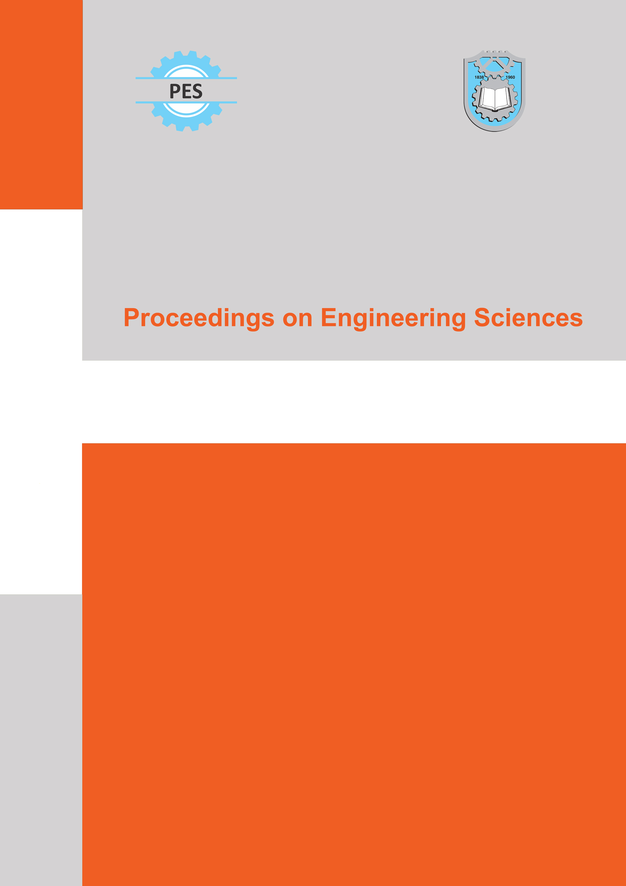

Authors ORCID Information | 
As part of our efforts to improve transparency in authorship, we request that all authors/coauthors of published papers provide their Open Researcher and Contributor Identifier (ORCID) iD at the time of publication.
Application for an ORCID is free of charge and only takes a few minutes - please go to ORCID.org to apply for one. We also recommend that the corresponding author contacts all of his coauthors and encourages them to obtain an ORCID.

All information required below must be completed for each author
Author |  | Affiliation | Email | ORCID iD 
Name | Last name | Affiliation | Email
We strongly believe that the increased use and integration of ORCiD identifiers will be beneficial for the whole research community.

